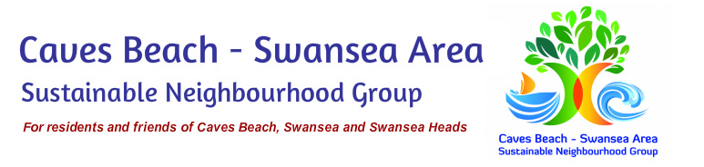CALM’D (Coast And Lake Marine Debris) School Art Competition

The Caves Beach - Swansea Area Sustainable Neighbourhood Group (CBSASNG) are organising an art competition and exhibition for local schools to be held 8 September - 22 October 2017.

The competition invites local schools to participate by producing artworks from marine debris collected from our local parks and foreshores.
This initiative seeks to raise awareness of and educate the children about the environmental impact of marine debris while also providing an opportunity for creative expression.
The exhibition will showcase works created by the children and will be held in the Swansea Community Centre from 20 - 22 October 2017. Selected art works will then be exhibited for one week in Swansea Library and the Finite Art Gallery, Caves Beach.
We are currently seeking donations from local individuals, organisations, and businesses. You can support by a monetary donation or by providing goods and/or gift certificates to be used as prizes for winning entries. If you prefer, cash donations can be made easily and simply via direct bank deposit.
Account name: Caves Beach Swansea Area Sustainable Neighbourhood Group
Newcastle Permanent
BSB: 650-000
Account number: 516813803
If you could please provide your details below we will acknowledge your sponsorship on our Facebook page, website, and at the exhibition. We will be sure to send a reminder email to attend the event closer to the date.
Kind regards,

Ross Woods
Chairperson and Secretary, Caves Beach Swansea Area Sustainable Neighbourhood Group
CavesBeachSwanseaArea@gmail.com
www.sustainableneighbourhoods.org.au/caves-beach-swansea-area

Company Name / Family Name __________________________________________________
Contact email __________________________________________________
Pledge amount or gift details __________________________________________________

